PERSONAL INFORMATION | Pereiro Castrillón Néstor
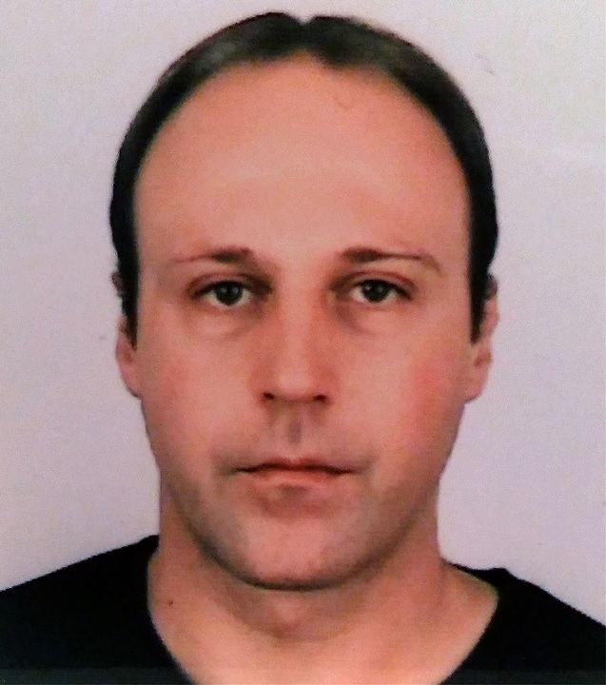

15002 A Coruña (Spain)

981205700  651350146

nestorpereiro@gmail.com
 | Sex Male | Date of birth 02 de octubre 1982 | Nationality Spanish

04/11/2019 – Present | Analyst Developer
04/11/2019 – Present | DSV Global Transport and Logistics – La Coruña (Spain)
04/11/2019 – Present | Analyst developer at DSV. Analyst developer at DSV. Different features analysis and further development for customs clearance management application, with C# and Entity Framework 6 as main technology.  SOAP/REST APIs consumption. Communication with tax agency over the webservices provided by them.

18/05/2017 – 31/10/2019 | Software developer
18/05/2017 – 31/10/2019 | Globeducate - Madrid (Spain)
18/05/2017 – 31/10/2019 | Software developer at NACE Schools, reporting with ReportViewer using C# and needed configuration controls developing, designed to complement official documentation required.  User web controls building, involving the use of DevExpress components and different additional technologies like JavaScript, jQuery and Ajax.

19/07/2016 – 17/05/2017 | Analyst Developer
19/07/2016 – 17/05/2017 | Atos- Madrid (Spain)
19/07/2016 – 17/05/2017 | Programmer Analyst at Atos for BBVA. New functionalities over application tasked with handling entity inventory, as well as reports generation needed for auditing purposes.  Data import from csv files to database using SQL Server Integration Services packages and Oracle connections.

07/12/2015 – 24/06/2016 | Analyst Developer
07/12/2015 – 24/06/2016 | Everis- Madrid (Spain)
07/12/2015 – 24/06/2016 | Programmer Analyst at Everis for Santander bank. Analysis and new developments for Basel banking regulation application.  The software developed in C# and VB .NET, extracts and processes data from Excel books generating outputs for other systems.

WORK EXPERIENCE
20/10/2014 – 04/12/2015 | Software developer
20/10/2014 – 04/12/2015 | Capgemini - Langreo (Spain)
20/10/2014 – 04/12/2015 | Software developer at Capgemini for Endesa, modifications of programs responsible of managing different types of documents used for tasks organization purposes.  Modules migration from Visual Basic .NET to C#, adaptation and improvement of the implemented operativity.  Project integration, source code and database elements unification.

26/08/2013 – 17/10/2014 | Software developer
26/08/2013 – 17/10/2014 | Efor – O Porriño (Spain)
26/08/2013 – 17/10/2014 | Software developer at Efor for Coren, new developments and necessary modifications to control production application created in Visual Basic .NET with JavaScript, XML and XSLT handling against SQL Server database with Visual Studio 2008 as development environment.  New stored procedures and altering existing ones due to application updates.  Reporting with Reporting Services 2008 and user´s requests resolution.

01/12/2010 – 30/11/2011 | Software developer
01/12/2010 – 30/11/2011 | Tecnocom, La Coruña (Spain)
01/12/2010 – 30/11/2011 | Programmer at Tecnocom for Caixa Galicia, maintenance and inclusion of new functions in the GEMA web application (Multiple Automated Management) in charge with the contracts and invoices control for their adaptation to the new entity resulted from the merger with Caixanova. The application was developed with C # and ASP technologies. NET framework 2.0 against SQL Server beside the use of webservices and custom controls, working with Visual Studio 2005.  Development of other software required for communication with other groups, such as batch programs or XML readers, using the same technologies described above.

15/11/2009 – 15/08/2010 | System technician
15/11/2009 – 15/08/2010 | University of La Coruña, La Coruña (Spain)
15/11/2009 – 15/08/2010 | Responsible for the Internet Classroom in the Nautical and Machines Faculty at the University of La Coruña. Users support and maintenance of computers and printers.

01/08/2007 – 31/12/2008 | Software developer
01/08/2007 – 31/12/2008 | Coremain, La Coruña (Spain)
01/08/2007 – 31/12/2008 | Programmer in Coremain for R Telecommunications, creating new features for various internal programs, especially for SIOT (Print System Work Orders), which printed in pdf the data for the installers technicians in Visual Basic 6.0 against Oracle, development of functions, triggers, stored procedures and query optimization, in addition to specific jobs in C # and Visual Basic. NET .

EDUCATION AND TRAINING

01/10/2005 – 01/06/2007 | Advanced Vocational qualification in Management Information Systems
01/10/2005 – 01/06/2007 | Fernando Wirtz Suárez, La Coruña (Spain)
01/10/2002 – 01/06/2004 | Advanced Vocational qualification in Computer applications development
01/10/2002 – 01/06/2004 | Fernando Wirtz Suárez, La Coruña (Spain)
01/10/2001 – 01/06/2002 | Advanced Vocational qualification in the Secretarial studies
01/10/2001 – 01/06/2002 | Mixed school Caixa Galicia, La Coruña (Spain)

PERSONAL SKILLS

Mother tongue | Spanish
Other language(s) | UNDERSTANDING |  | SPEAKING |  | WRITING
Other language(s) | Listening | Reading | Spoken interaction | Spoken production
English (FCE) | B2 | B2 | B2 | B2 | B2
German | A2 | A2 | A2 | A2 | A2

ORGANISATIONAL SKILLS

15/09/2016 – 28/10/2016 | Volunteering in diabetes association
15/09/2016 – 28/10/2016 | Diabetes association, Madrid (Madrid)
15/09/2016 – 28/10/2016 | Support in database creation for the management of the partners and the different activities offered by the association.

COMPUTER SKILLS

2020 | Microsoft Certified: Azure Fundamentals (MCP Id: 10090133).
2018 | Programming in HTML5 with JavaScript and CSS3 (MCP Id: 10090133).
2016 | OCP: Oracle Database 12c Administrator Certified Professional (id: OC0829061).
2013 | MCSA: SQL Server 2012 (MCP Id: 10090133).
2013 | Oracle Certified Expert, Oracle Real Application Clusters 11g and Grid Infrastructure Administrator (id: OC0829061).
2012 | Linux LPIC-1 (id: LPI000262144).
2012 | Oracle Certified Professional, MySQL 5 Database Administrator (id: OC0829061).
2012 | Oracle Database 11g Performance Tuning Certified Expert (id: OC0829061).
2012 | OCP: Oracle Database 11g Administrator Certified Professional (id: OC0829061).
2010 | SCJP: Sun Certified Java Programmer (id: SUN627947).

